Scenario 7: How to Delete EC2 placement groups in AWS.
A placement group is essentially a logical grouping of EC2 instances for specific networking/placement strategies (cluster, spread, partition).
AWS won’t let you delete a placement group if there are still active instances inside it. Those instances are tied to the group.
Steps
- Terminate or move instances
  - If you don’t need the instances anymore → terminate them.
  - If you want to keep them but not in the placement group → you’ll need to stop and relaunch them outside of the group (placement group membership is fixed at launch).
- Delete the placement group
  - Once no instances are associated, you can delete the group.
Note
- You cannot “detach” an instance from a placement group; you must terminate and relaunch it outside the group.
- Deleting the placement group does not affect other EC2 resources in your VPC.
- After deletion, the placement group name is freed up and can be reused later.

Step 1: select placement groups.
Ec2 console, under Network & Security > select Placement Groups
Select the placement groups which were created eariler and click on actions> delete.
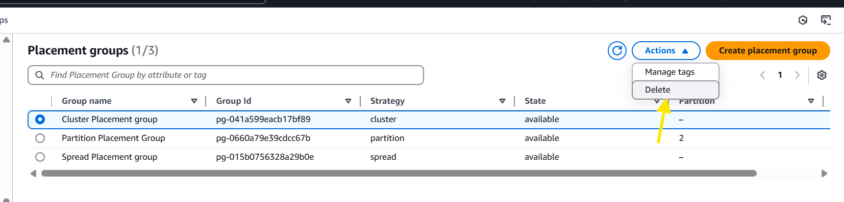
Step 2: continue the same for remaining placement groups.
